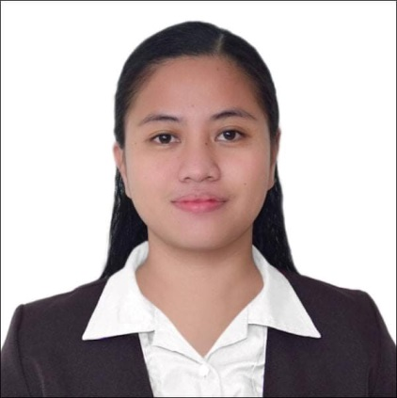**MARJORIE DIZON MENDOZA**

Rizal, Roxas, Isabela

Mobile Number: 09386120090

E-mail Address: mendozamarjorie0328@gmail.com

OBJECTIVE:

To enhance of my knowledge and skills to become a part of a good team so that I could learn more and improve my personal, intellectual and social skills.

EDUCATIONAL BACKGROUND:

TERTIARY: Bachelor of Secondary Education Major in MAPEH

Isabela State University- Echague Campus

San Fabian, Ecahague, Isabela

2015-2019

SECONDARY: Roxas National High School

Bantug, Roxas , Isabela

2011-2015

ELEMENTARY: Roxas Central School

Rizal, Roxas, Isabela

2005-2011

COLLEGIATE AND COMMUNITY EXPERIENCE:

* NCCA’s Dance Workshop of the Dance Xchange: Philippine International Dance Workshop, 2017 C
* Isabela District 4 celebration on National Women’s Month
* Officiating Official ISU-Santiago Extension Campus Intramurals, 2018
* Off-Campus Internship, January-April 2019

WORK EXPERIENCE

* Department of Social Welfare and Development FO 02- Listahanan Enumerator
* Cashier ( Sanford Marketing Corporation)
* Volunteer Teacher ( 2020-2023)

PERSONAL SUMMARY

Good team skills and interpersonal skills, good team cooperation. Quick learner who can absorb new ideas and can communicate clearly and effectively. Multi skilled with an ability to build strong working relationships with fellow workers and a good team player, always willing to accept responsibilities beyond the line of duty, with passion.

CORE COMPETENCIES

* Highly organized and efficient
* Computer Literate
* Ability to work independently or as part of a team
* Public Relations
* Experiential Learning

CHARACTER REFERENCES

* Fernando R. De Villa Jr

Regional Director

* Elector G. Dumaguing

Principal II

I hereby certify that the above information is true and correct to the best of my knowledge and belief.

MARJORIE D. MENDOZA

Applicant